+-+-+-+-+-+-+-+-+-+-+-+-+-+-+-+-+-+-+-+-+-+-+-+-+-+-+-+-+-+-+-+-+-+-+-+-+
Mansoor Zafar
100503226
mzafar15@myseneca.ca

+-+-+-+-+-+-+-+-+-+-+-+-+-+-+-+-+-+-+-+-+-+-+-+-+-+-+-+-+-+-+-+-+-+-+-+-+
Table of Contents:
- Part A (Air Traffic Control Tower)
[Pages 1 - 11]
  - Page Design
  - Annotations
- Part B (Cognitive Walkthrough)
[Pages 10 - 14]

+-+-+-+-+-+-+-+-+-+-+-+-+-+-+-+-+-+-+-+-+-+-+-+-+-+-+-+-+-+-+-+-+-+-+-+-+
Part A
Page: Air Traffic Control Tower Home (Home Page)
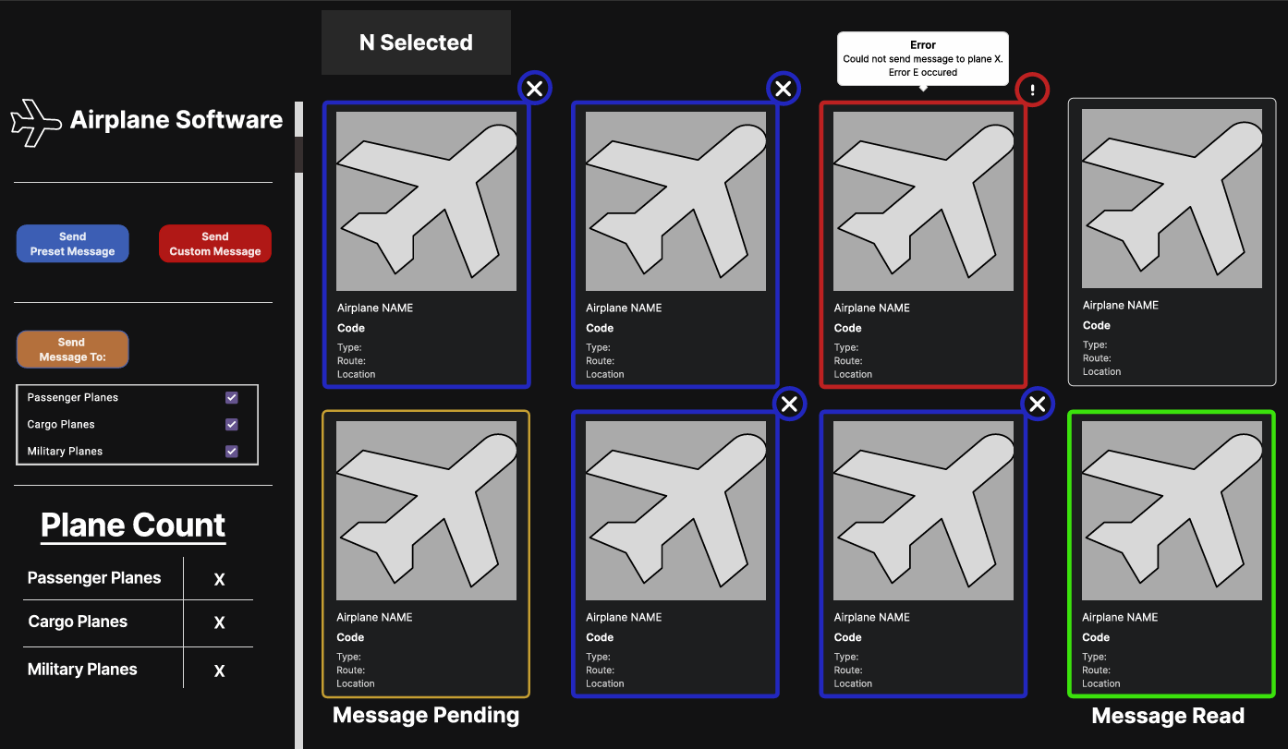
- Selecting multiple airports
By default, all the airplanes will look like this when not selected or no status information is with them.
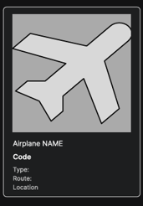
When a user clicks on any of the airports shown, it’ll be highlighted in blue and have an ‘x’ icon at its top right corner.
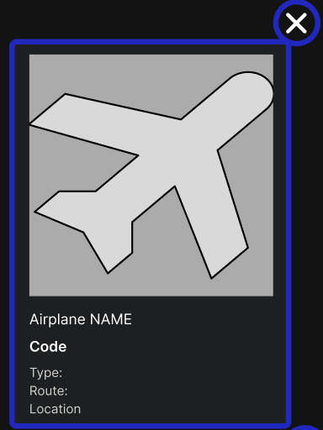
As you select airplanes, the N Selected, will update with the number of items that are currently selected.

When the user tries to select either of the sending messages, “Send Preset Message”, or “Send Custom Message” with no plane selected, this popup will appear and block the input.
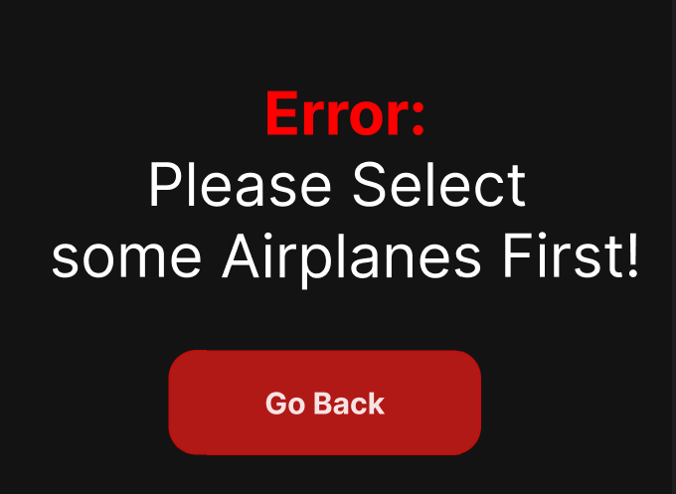
- This popup shows the error message that no plane was selected, and lets the user go back to the home screen to then continue.
Deselecting Planes:
When the user clicks the ‘x’ at the top right of the selected plane

It will lose the highlight and turn back to the regular style of default

And the N Selected text will update to reflect the now current number of selected planes


When the user clicks the

button and only has one of the checkboxes selected and multiple plane types selected, then only the desired plane types and only selected will get the message.

- Sending Preset Message

When the user clicks this button, as mentioned above, if it doesn’t any plane selected, it will give this popup.

When the user clicks the “Go Back” button, it will return them back to the main page they were just on.
After some planes are selected and the button is pressed, a confirmation popup will appear to allow the user a chance to backout.
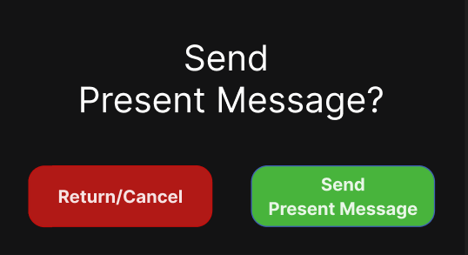
If the user selects, “Return/Cancel”, they will be sent back to the home page, but if they select the “Send Present Message” button, they will get this short popup.
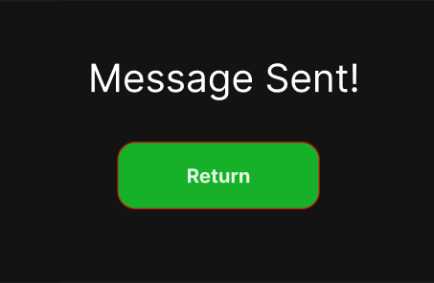
This will give the user confirmation that the message was sent successfully, and when they click return, it will return the user back to the home page and update the plane to look like this.
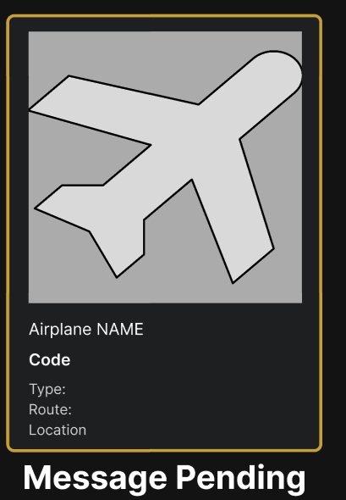
It will highlight the plane in yellow and add the text of message pending, meaning the message was sent but the receiver hasn’t read it yet.
However, if something goes wrong when sending trying to send the message, this will display instead.
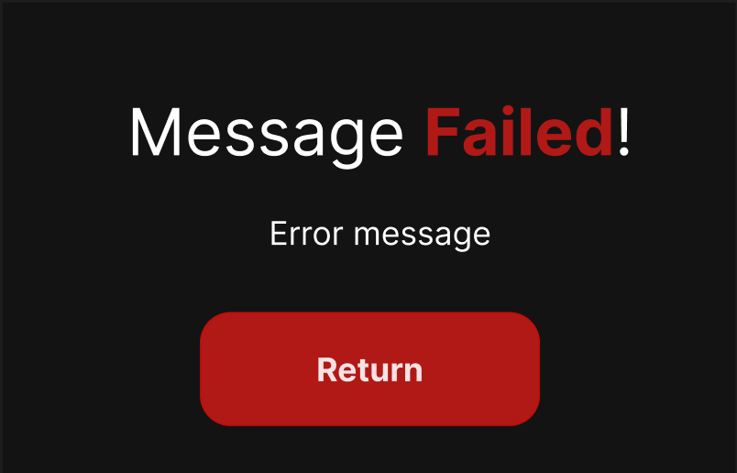
This shows an error message with the text of the message being failed. This will also update the plane to look like this.
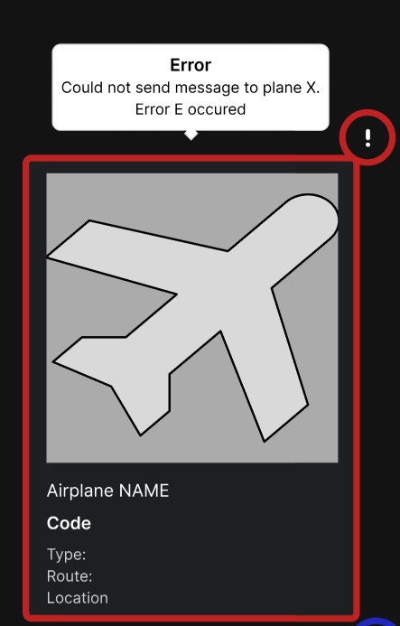
When the receiver reads the message, the plane’s design will be updated to a greener look and update the text to Message Read.
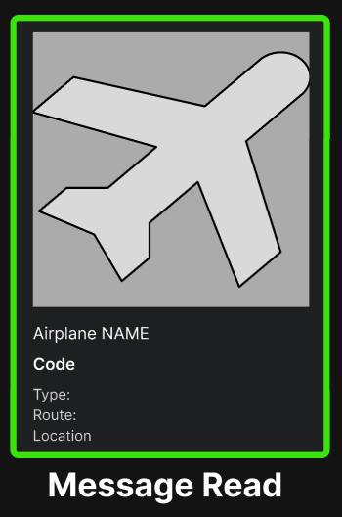
- Sending Custom Message

When the user clicks this button, they will be shown this popup,
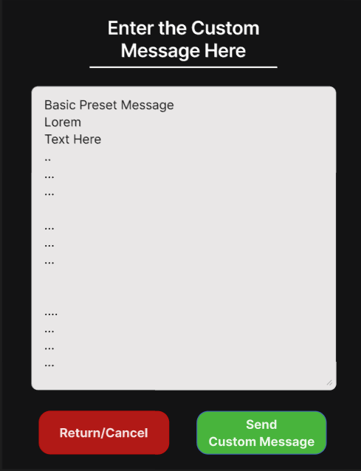
If the user clicks the Return/Cancel button, they will be sent back to the home page. But if the user clicks the Send Custom Message and has an empty text area, so they left it blank and didn’t input any text, they will get this popup.
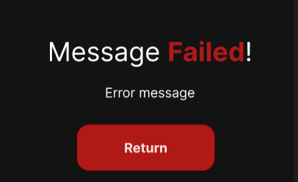
The error message would be that the message cannot be blank, and when they click return, it’ll bring them back to the popup with the custom text. When the user enters valid text, and clicks the send custom message button, the green one, and the message was successful, then they will get this popup.
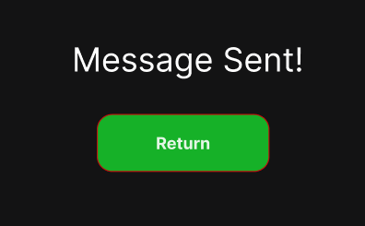
When the user clicks return, it will send them back home and update the plane(s) to be in the pending status as so

However, if something goes wrong when sending trying to send the message, this will display instead.

This shows an error message with the text of the message being failed. This will also update the plane to look like this.

When the reciever reads the message, the plane’s design will be updated to a greener look and update the text to Message Read.

- Sending a Message based on passenger type
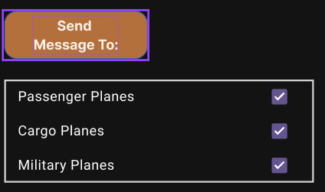
By default, all the options are selected as you will send a message to all types of planes. Here, the user can de-select or select any checkbox and add or remove them from the list of sending. If the user selected Passenger planes, and clicks send Message to button, then only the passenger planes would get a preset message. When they click the Send message to button, follow the sending preset message steps so:


If the user selects, “Return/Cancel”, they will be sent back to the home page, but if they select the “Send Present Message” button, they will get this short popup.

This will give the user confirmation that the message was sent successfully, and when they click return, it will update the plane to look like this.

It will highlight the plane(s) in yellow and add the text of message pending, meaning the message was sent but the receiver hasn’t read it yet.
However, if something goes wrong when sending trying to send the message, this will display instead.

This shows an error message with the text of the message being failed. This will also update the plane(s) to look like this.

When the receiver reads the message, the plane(s)’ design will be updated to a greener look and update the text to Message Read.


- Airplane Count for Each Type
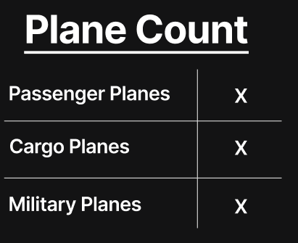
- These values will dynamically update as the user loads more content as they show how many planes belong to which type while they are on screen

+-+-+-+-+-+-+-+-+-+-+-+-+-+-+-+-+-+-+-+-+-+-+-+-+-+-+-+-+-+-+-+-+-+-+-+-+
Part B
Step 1:
- Home Page
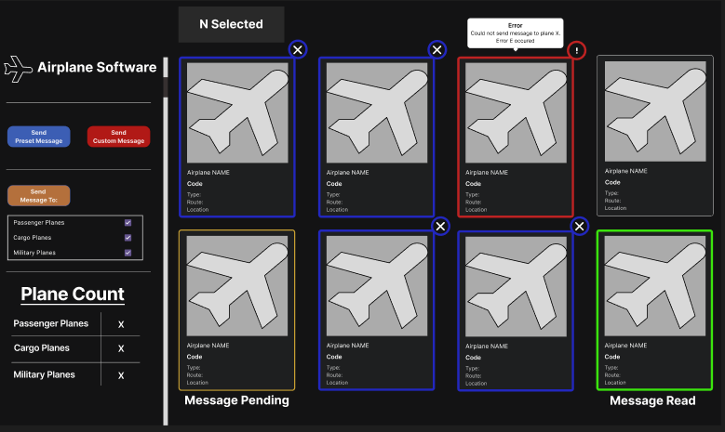
  - The user starts by selecting airplanes A, B, E and F with all of them being in the default state like
  -  An example of what the plane looks like in the default state
- When selecting them, they will be highlighted as so,
  - Airplanes A, B, E and F will be highlighted like in the picture
    - The “N Selected” at the top
    - 
      - Will now say 4 Selected
Step 2
  - The user then clicks the ‘X’ for airplanes F and E
    - They now become deselected and return to the default state of
      - 
      - And the “N selected” updates alongside with it to say 2 Selected
        - 
        - Now only airplanes A & B are selected
        - 
Step 3
  - The user then clicks “Send Preset Message”
    - 
    - The user will then be brought to the sending a preset message confirmation popup
      - 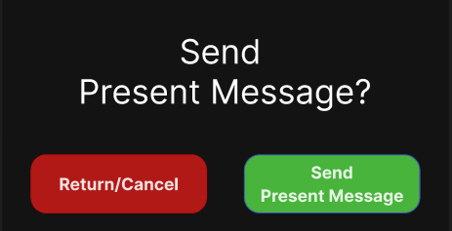
Step 4
  - The user then clicks Send
    - The user then gets a popup notifying them it was successfully sent
      - 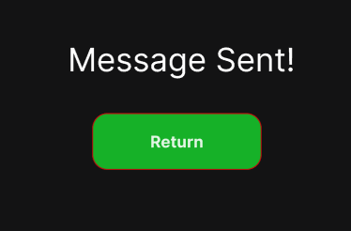
Step 5
      - The user then clicks Return to go back to the home screen
        - 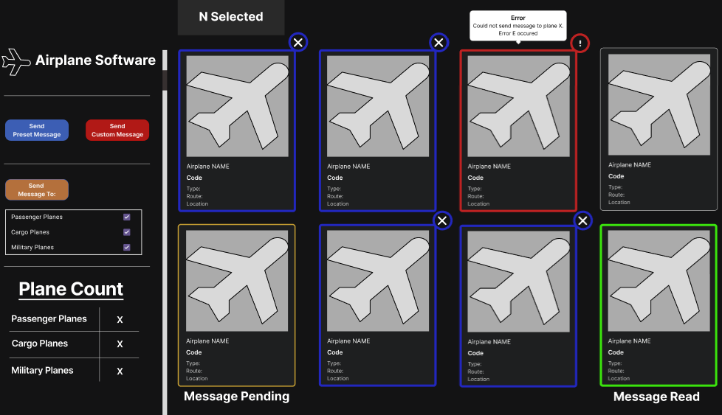
      - Airplanes A & B are updated to have a yellow outline and have the message “Message Pending” set underneath them as so
        - 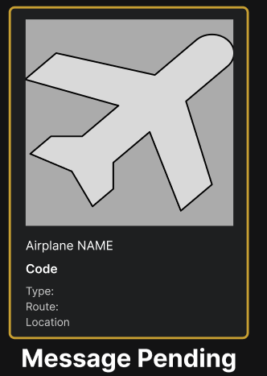
Step 6
  - The Receiver then reads the message
    - The airplanes are updated with a green status indicating they were read and have the message, “Message Read” underneath them
      - 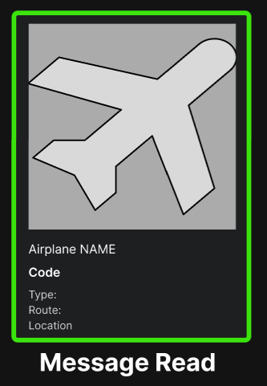
        - Both airplanes A & B will show this

